Dal Santo’s Sausage & Catering
Specializing in homemade Italian food!

976 E. Steger Rd (708)367-0070
Crete, IL 60417

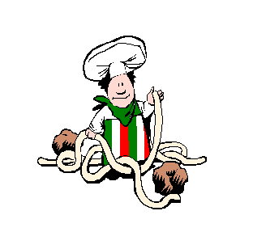

Sandwiches

Sausage . . . . . . . . . . . . . . . . . . . . . . $5.00

Beef . . . . . . . . . . . . . . . . . . . . . . . . . $5.00

Combo (Sausage & Beef) . . . . . . . $6.50

Meatball . . . . . . . . . . . . . . . . . . . . . $5.00

*** hot sandwiches come with choice of one cheese, mild or
hot pepper spread, and/or red sauce***

Italian Sub . . . . . . . . . . . . . . . . . . . . $4.50
(Capicolla, mortadella, salami, provolone & muenster cheese)
American Sub . . . . . . . . . . . . . . . . . $4.50
(Ham, beef, turkey, american & swiss cheese)

